Account opening operations
Target customer group: corporates which make use of electronic mode of transfer, no cash involved
- Sales staff conducts business development activities to look for potential clients.
- Sales staff creates internal customer record.
- Sales staff conducts preliminary evaluation based on information provided by client.
- If sales staff and client reach a consent to open an account with TC, sales staff sends an onboarding form (Appendix 1) for client to fill in and for signing.
- Sales staff notifies client all the information and documents required for account opening. Please see Appendix 2 for the list of information required.
- Client may choose to create an online account by themselves thru the website of TC (https://my.transferclear.com) or submit all required information to sales staff to create the online account.
  - For client who creates their own online account, they would complete the following tasks:
- Create own username and password
- Verify email address and phone number
- Input all required fields in the system
- Upload required documents
- Verify own information with Sumsub embedded in the system
  - For client who assign TC to create the online account, operation staff would complete the following tasks:
- Receive information and documents from client from the sales staff or client through email
- Create username for client
- Input details (such as corporate, UBO, shareholder and director) of client into the system
- Sumsub sends link to client for KYC checking
(each client may create additional user accounts once the account is fully approved)
- Onboarding Team staff stores all the relevant information and documents in the operation system.
- If the information or documents provided by client are faulty or inadequate, onboarding team staff send an email to make request.
- Based on the background and business nature of client and the internal AML policies, compliance team assigns a risk profile (low, medium or high) to this client. Further due diligence will be conducted on client with a medium- or high-risk profile by the compliance officer of the onboarding office.
- If compliance officer has approved;
  - a medium or high-risk client, he/she will send an email to management to conduct further review and approval. Once the compliance officer has obtained senior management approval, compliance team will inform the operations and onboarding team that KYC is completed and approved so that operation team will work on the account set-up.
  - a low-risk client, compliance team will send an email to operations and onboarding team that the KYC is complete and approved so that operation team will work on account set-up.
- For fully approved client, operation system allows client to operate its online account through https://my.transferclear.com.
- For disapproved client, operation staff informs customer, updates the system and separates customer files in another folder.
- Operation staff liaises the bank to create an account for the approved client, later updates the bank details on the online account.

Appendix 1 (P1)
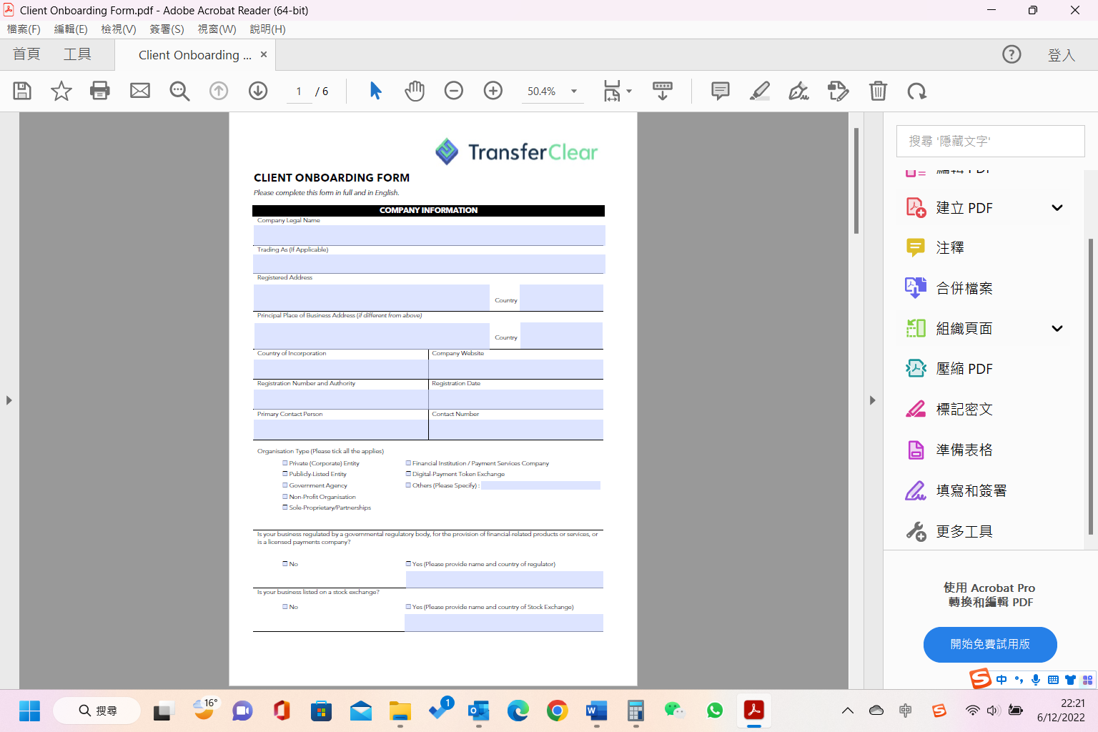
Appendix (P2)
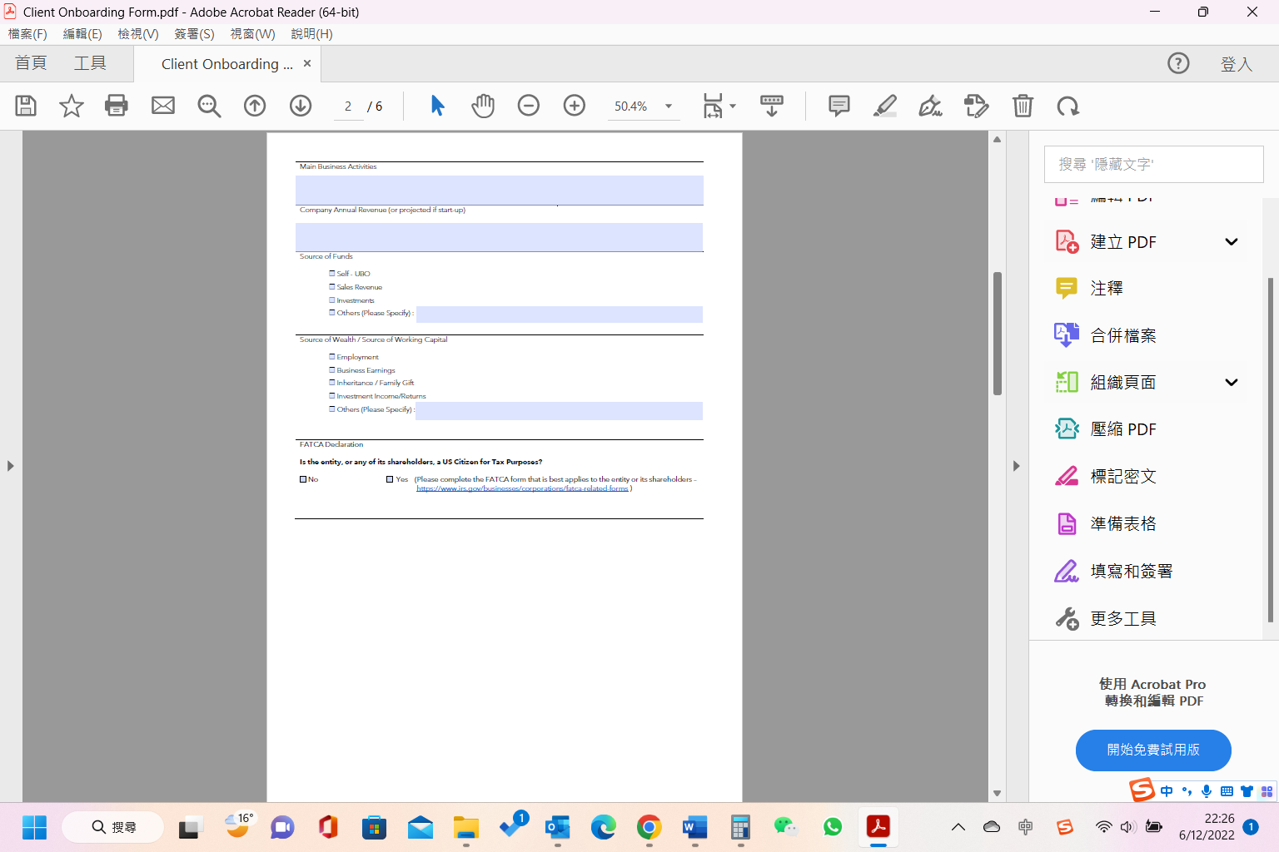
Appendix (P3)
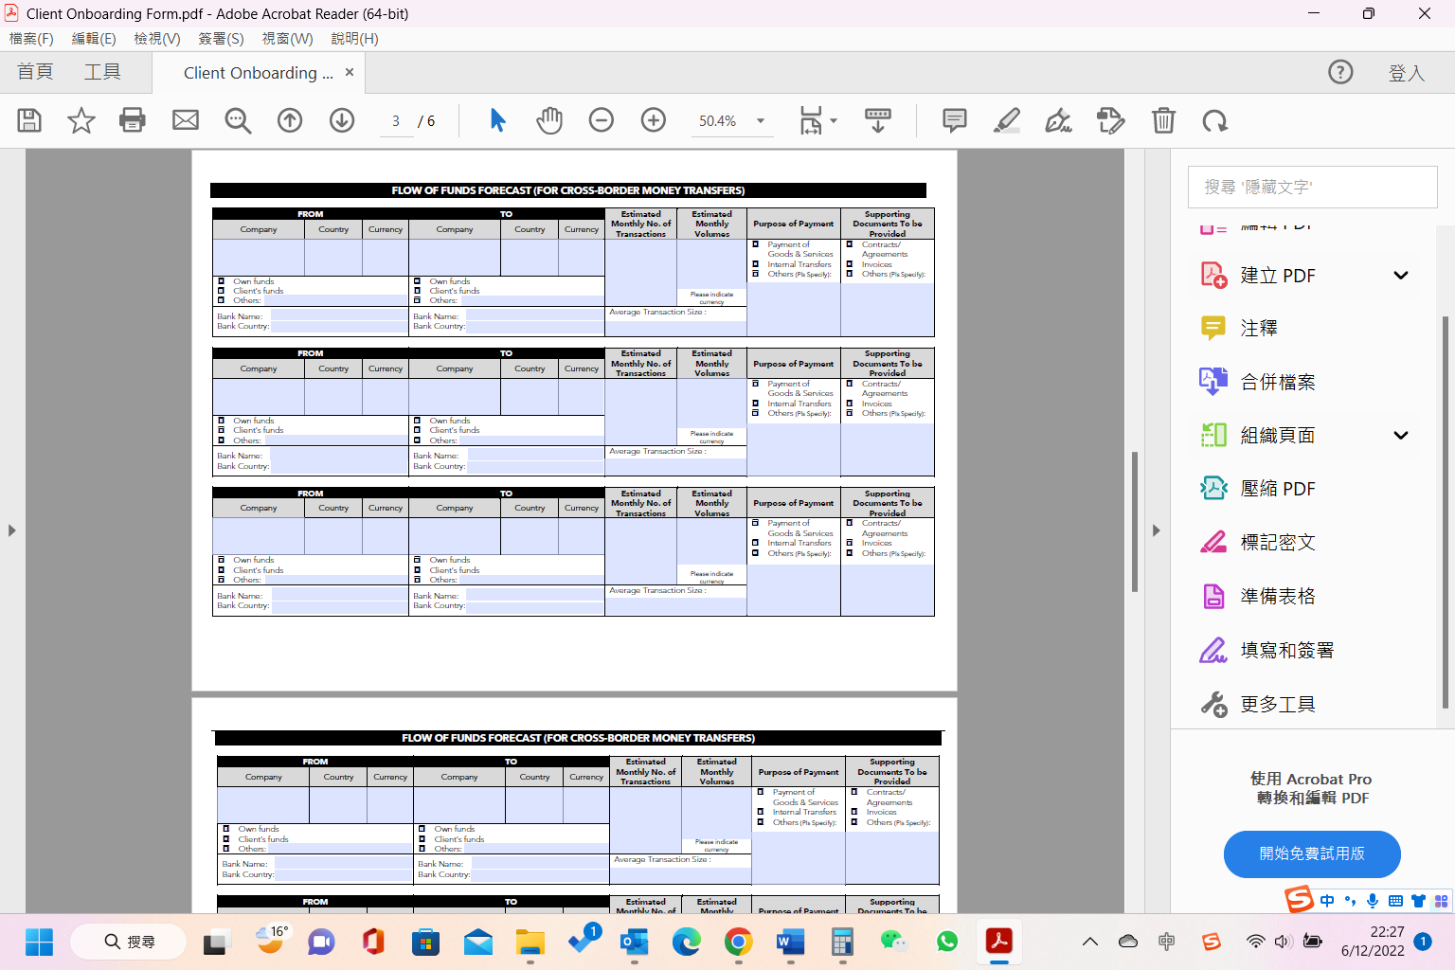

Appendix (P4)
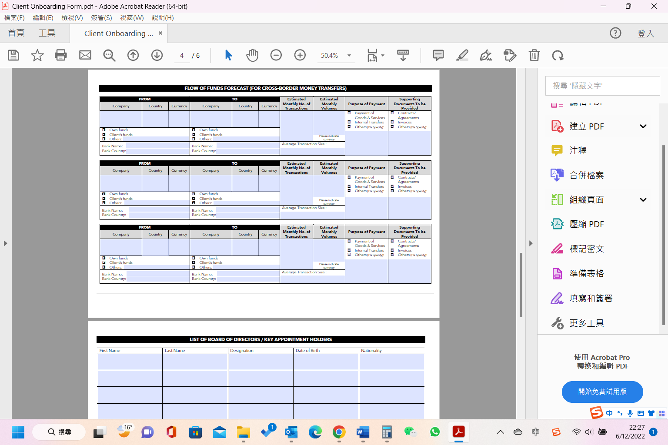

Appendix (P5)
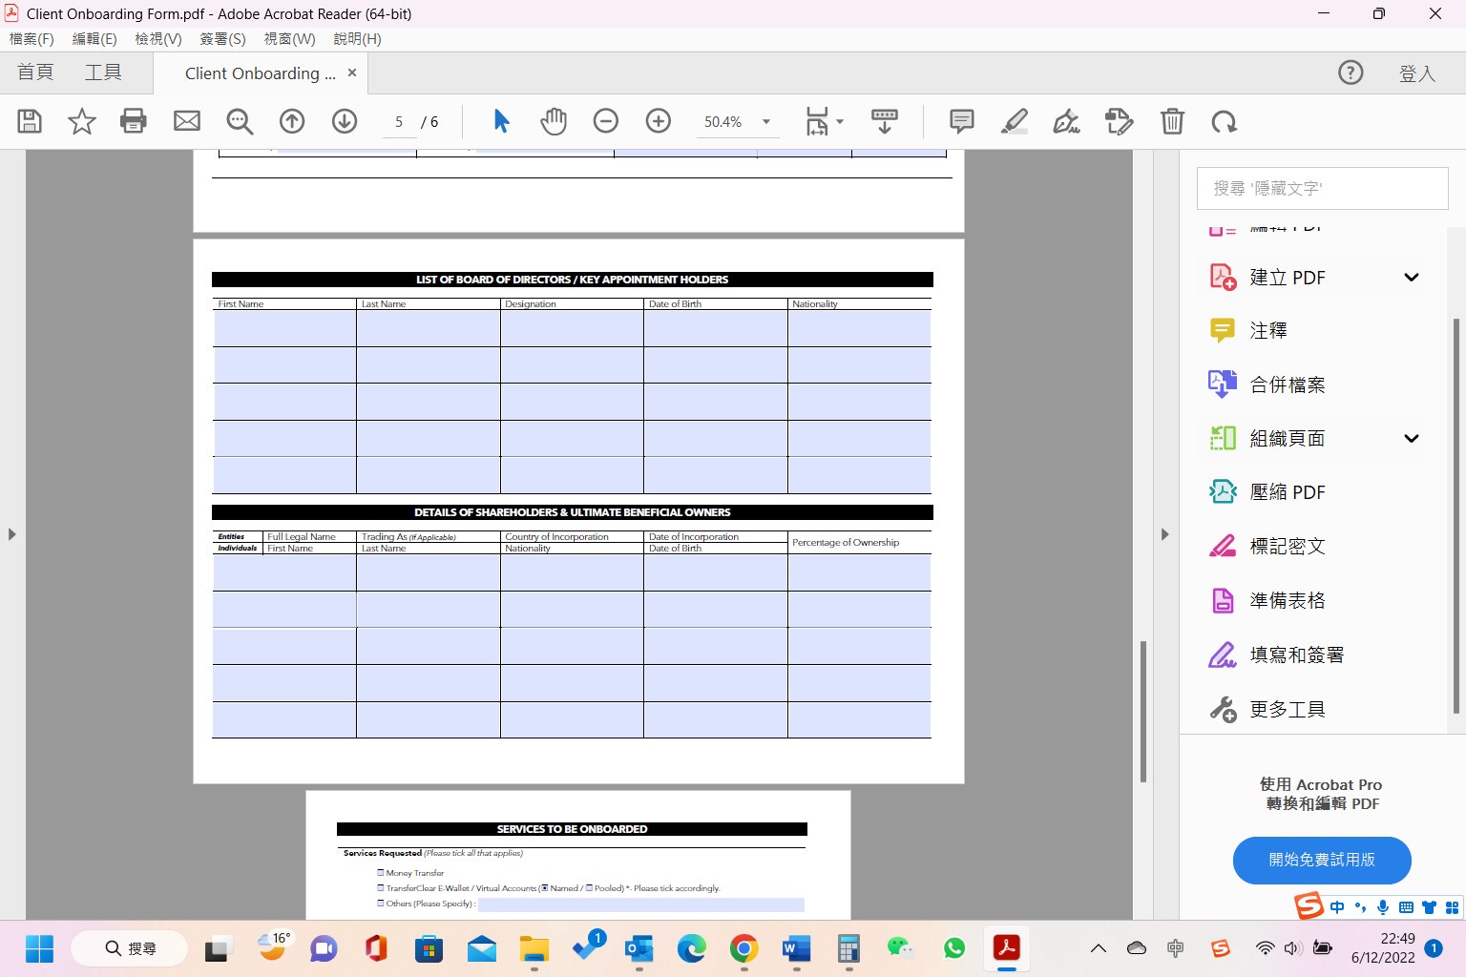

Appendix 1 (P6)
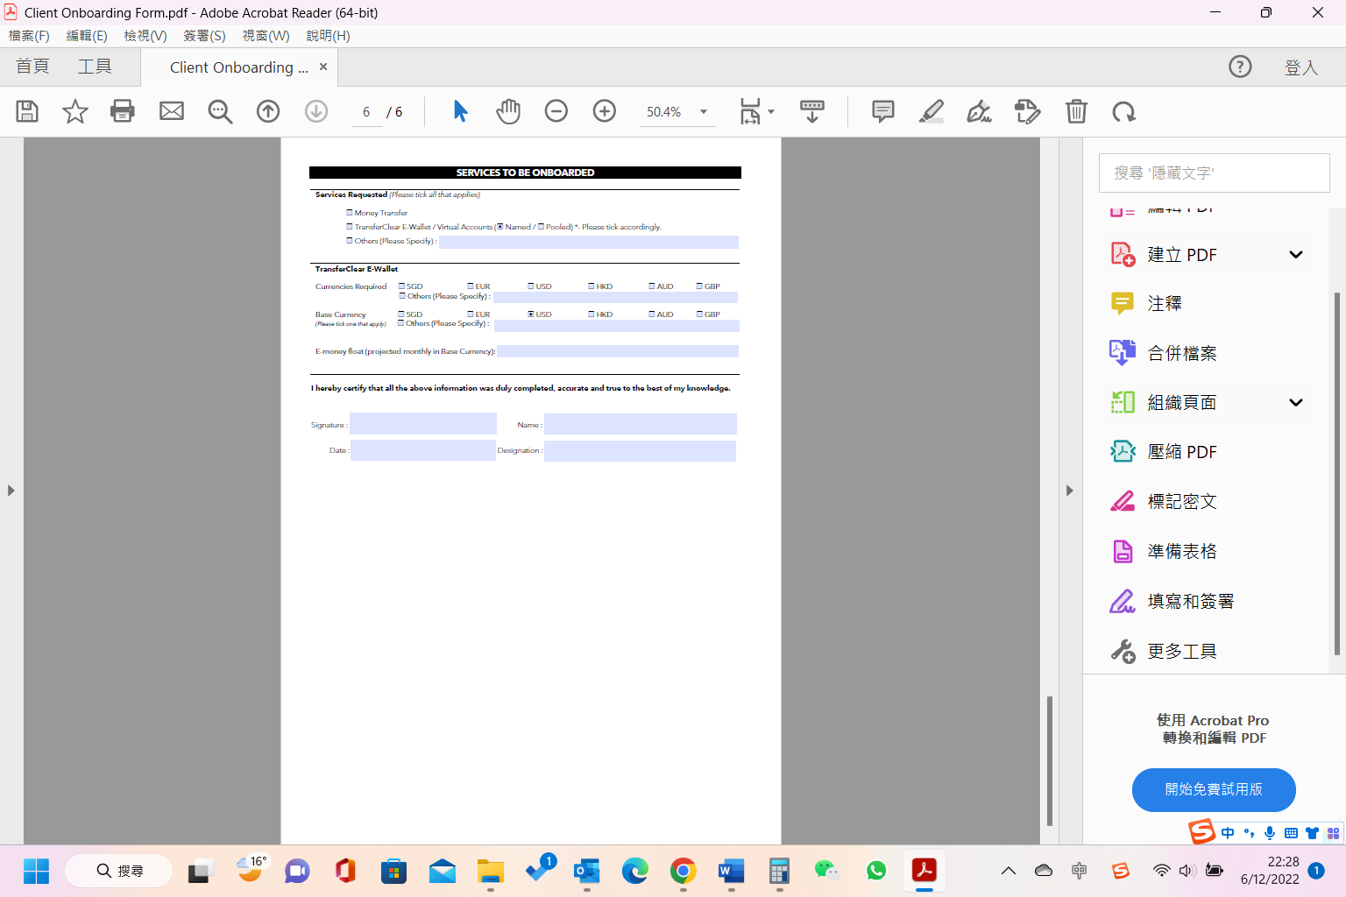
Appendix 2

ONBOARDING CHECKLIST FOR INTERNATIONAL ENTITIES
All documents must be in English and copies certified by a legal and/or professional authority, or sighted by one of our TransferClear team members.

    - Government-Issued Company Registration Document
- Must include information of the company’s
- Full legal name;
- Business address and/or principal place of business;
- If shareholder is a company, to provide company registration document of Ultimate Beneficial Owner (s)

    - List of Authorised Personnel
- Board Resolution (Refer to template)
- Letter of Authorisation and Indemnity (Refer to template)

    - Valid Government-Issued Photo ID / Passport copies and Proof of Address (If not in ID) of all Authorised Personnel from Items 1 & 2.

    - Documents from the Local Government Business Registry
- Certificate of Good Standing or equivalent
- Certificate of Incorporation or equivalent

    - Memorandum and Articles of Association

    - Company Drafted Documents
- Full Ownership and Control structure
- Flow of funds (to include details on source of funds, estimated volumes, jurisdictions, and purpose of transfer)

    - Client Onboarding Form (Duly completed and signed)

    - Proof of Company Address

